**Cyber Security Essentials by LetsUpgrade**

Assignment -1

1.Find out the mail servers of the following domain: (i)Ibm.com, (ii) Wipro.com.

Below are the Findings.

Using Nslookup , found the mail servers for ibm.com & Wipro.com

Using command Set type=mx

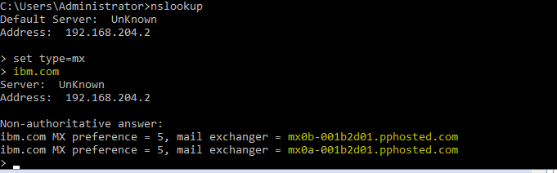

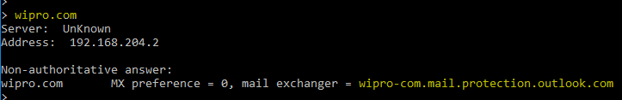

2.Locations and DNS servers of above mail servers.

Using Command – set type=ns

Below are the findings: -

1. For ibm.com

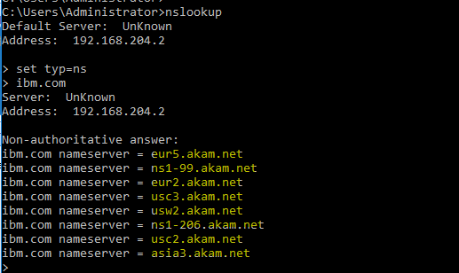

(ii). for Wipro.com

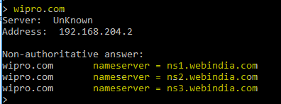

3. Scan and find out port numbers open 203.163.246.23\

